

**Feedback and Marking Policy:**

**Reviewed: September 2021**

**Approved: September 2021**

**Review: September 2022**

Aims

* To encourage children to progress and ultimately, flourish in their learning
* To give children effective feedback on their learning
* To enable children to celebrate success
* To achieve a consistent approach to marking across the school
* To form part of the formative assessment procedures
* To inform future planning

Objectives

* To relate to the learning intention of the lesson
* To assess the learning of the children
* To plan in time for children to read and respond to marking
* To feedback effectively, both verbally and through marking, during guided group activities, dealing with misconceptions and extending learning
* To teach children acceptable methods of presentation
* To develop children’s ability to self-evaluate and peer-evaluate their written learning.

Marking Principles

* Marking should indicate whether the learning was independent, part of a group, or through guided group work with the teaching assistant or class teacher; I, TA, S, CT or group should be clearly indicated.
* Marking should focus upon giving timely effective feedback on learning and be kept to a minimum
* Green highlighter is used to show success against the learning objective. Yellow highlighter is used to show areas for development.
* Some marking should occur during the lesson to ensure that misconceptions are identified and corrected
* Symbols will be used where appropriate (Annex A)
* Spelling errors will be indicated according to individual children’s needs. For example, common exception words, topic words.

Pupil Response

* Pupil Response is varied dependent on subject or age of pupil. Children are encouraged to respond to feedback and self-edit. This skill develops as children progress through the school.
* Children use green pen to self-edit.

Annex A

**Marking Symbols**

a b c

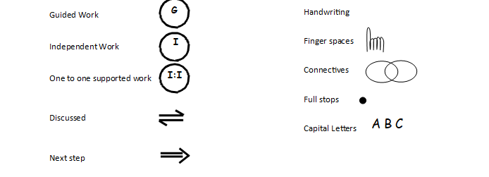

Spelling SP

A

!

?



V

Vocabulary 